# Fluid mover (pump/compressor)

# Type of pump

There are four types of pumps being considered, a reciprocating pump, an axial pump, a centrifugal pump, and a rotary pump. To determine which one is better suited for the design we must look at flow rates, pressure range, cost, head range, and efficiency.

A **reciprocating pump** is widely used for compressing gasses. It consists of a piston and a cylindrical chamber for the gas. The piston moves up and down using a rotor, sucking in the gas from the inlet valve, compressing it and then pushing it out of the outlet valve. It is a simple and cheap compressor to design and install. It can operate at high pressures and gets more efficient as its power requirement (work) increases. It can operate at 10-10000 gpm with a max head of a 1000000 ft. Its main drawback is that it causes pulses in the movement of the fluid, which is not optimal for when the fluid moves through heat exchangers and the reactor.

A **centrifugal pump** makes use of blades to accelerate the fluid and then slowing it down using a diffuser, this causes an increase in pressure. Centrifugal compressors can have a compact design and does not need a lot of maintenance. It gets more efficient as flowrate increases. Single stage Centrifugal compressors covers a flowrate range of 15-5000 gpm with a 500 ft max head.

A **rotary pump** makes use of screws or gears to continuously decrease the volume of the inlet flow which in turn increases the pressure of the fluid. The compressed fluid exists the pump at the outlet. Rotary pumps operate at 1-5000 gpm with a 50000ft max head. The always operate at moderate efficiency.

An **axial pump** is a type of centrifugal pump that can operate at high flowrates 20-100000 gpm. However, they can only have a maximum head of 40 ft. Axial pumps operates at moderate to high efficiencies.

The average volumetric flowrate going through the pump obtained from DWSIM is 0.605 m3/s (9589 gpm). We will use a compression ratio of 3:1 for this pump. The pump will increase the pressure from 30 bar to 90 bar.

The average density of the hydrogen going through the pump:

$$ρ_{ave}=\frac{ρ_{in}+ ρ_{out}}{2}=\frac{2.41787+5.04}{2}=3.729 kg/m^{3}$$

Densities from DWSIM:

Calculating the required head of the pump:

∆P = 60 bar = 6000 KPa

$$h=\frac{∆P}{ρg}= \frac{6000}{0.003729×9.807}=164068 m$$

164068 m = 538279 ft

The required head is extremely high due to the low density of hydrogen. The only pump that can go up to 538279 ft head is the reciprocating pump (max 1000000ft). It can also operate at the required flowrate of 9589 gpm (max 10000 gpm). **Thus, the only pump that will work in the design is the reciprocating pump.**

The power usage from DWSIM indicates 3552 KW. This well exceeds 500 hp (372.86 KW) which means the efficiency of the reciprocating pump will be very high. We will use a 90% efficiency (Adiabatic).

# Design of the reciprocating pump

## Sizing and rotational speed.

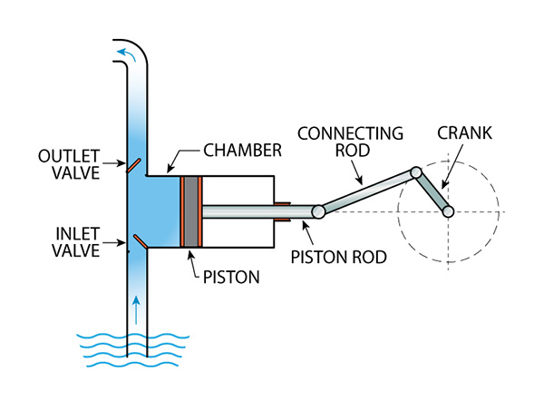

The layout of a reciprocating pump can be seen above. We need to consider the rotational speed of the crank and the volume of the chamber when designing the specifications for the pipe. Each full rotation of the crank causes one compression-expansion cycle for the piston. The rotational speed and the volume of the chamber needs to correspond to the required flowrate of the system. The outlet valve must be designed to only open when a pressure of 90 bar is reached.

For a polytropic systems the following equations stand:

With P1 and being the inlet pressure and P2 and being the outlet pressure. V1 is the volume before compression (maximum volume of the piston). And V2 is the volume after compression. W is the work of the pump/compressor and n is the polytropic coefficient. All the values of the equations can be found on DWSIM except for the 2 volumes. Both volumes are calculated simultaneously using the 2 equations.

n = 1.496

W = 3552.72 KW

P1 = 3000 KPa

P2 = 9000 KPa

Solving the volumes:

V1 = 1.6126 m3

V2 = 0.77374 m3

∆V = 0.83886 m3

Now we can calculate the rotational speed of the crank using the volumetric flowrate and the ∆V per cycle. This gives 0.7212 rotations per second (43.273 rpm) for the crank.

For the piston diameter-shaft-length, a well-accepted ratio is between 1:1 and 1:2. For higher pressures (like in this case) the diameter must be larger so the ratio will be closer to 1:1. Thus we will use a 1:1.1 ratio. V1 is used for the calculations as it is the max volume of the chamber.

$$V_{1}=πDL=πD(1.1D)$$

Solving D and L:

D = 0.683 m

L = 0.7514 m

## Pump curve

Pump curves for reciprocating pumps are near straight vertical lines that corresponds to a very specific flowrate.

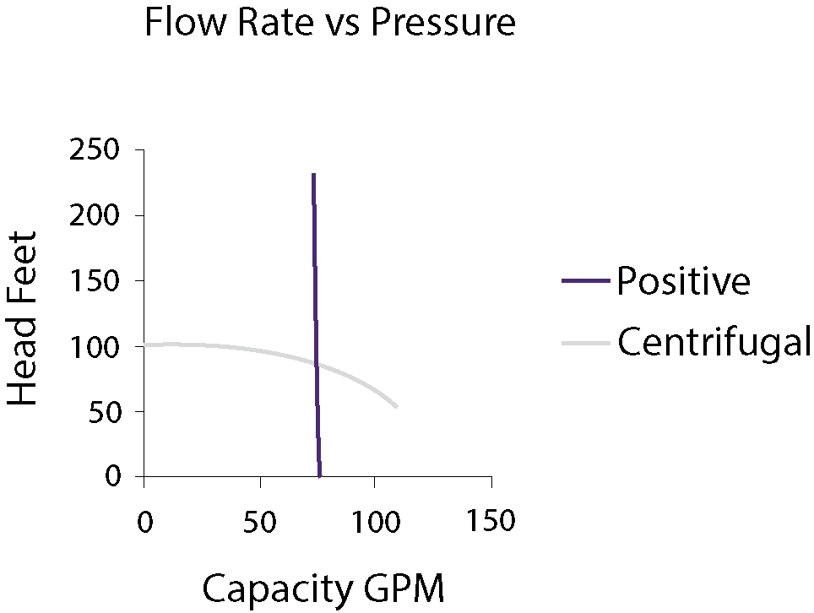

Positive displacement (reciprocating pump) curve vs a centrifugal pump curve.

For this design a rough estimate of the pump curve would look like this. The pump needs to be specifically designed for the required flowrate but can cover any head value up to 300000 m.

## NPSH